27.82: a)
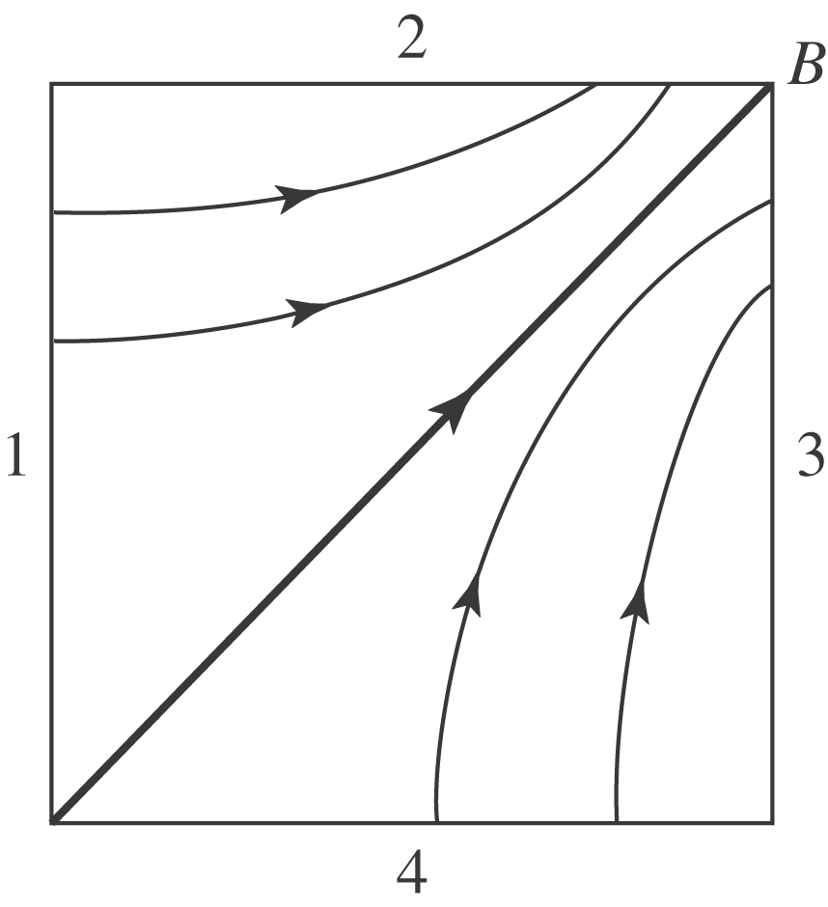
b) 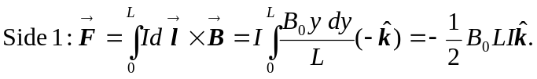
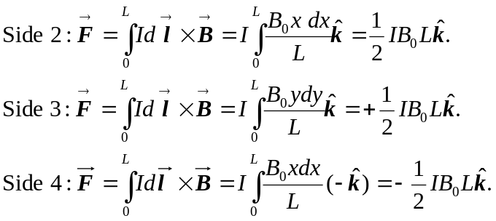
c) If free to rotate about the x-axis 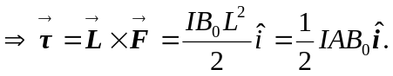
d) If free to rotate about the y-axis 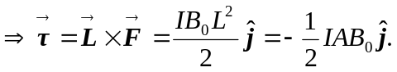
e) The form of the torque 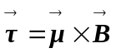 is not appropriate, since the magnetic field is not constant.

